Name: Rimsha Sana Rasheed
Section: D1
ID: 151
Submitted to: Sir . Talha Khalid

SHELL SCRIPT LAB TASK
Operating System
Simple calculator using a Bash script (Kali Linux)

Simple Calculator Shell Script
Objective: To write a Bash shell script that takes two numbers and a choice of operation from the user, and prints the result of add, subtract, divide or multiply.
Step 1: Write the script
nano calculator.sh
I created the script file calculator.sh using the nano text editor. The script first prints a heading with echo. It then reads two numbers into the variables num1 and num2 with the read command, and prints a menu of four operations: 1. add, 2. subtract, 3. divide, 4. multiply. The user's menu choice is stored in the variable choice.
A case statement then checks the value of choice. Each branch calculates the answer with Bash arithmetic, $(( )), stores it in result, and prints it. The case block ends with esac.
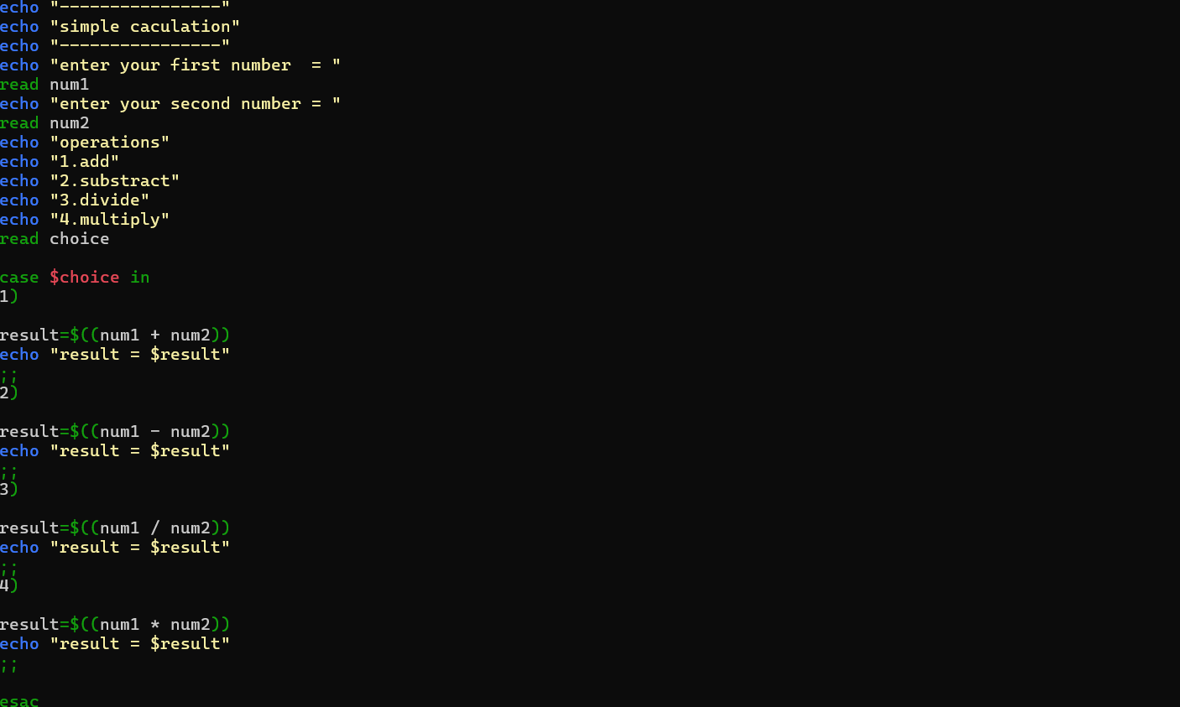
Figure 1: Source code of calculator.sh (case statement for the four operations)
How each choice works
Choice | Operation | Expression used
1 | Add | result=$((num1 + num2))
2 | Subtract | result=$((num1 - num2))
3 | Divide | result=$((num1 / num2))
4 | Multiply | result=$((num1 * num2))

Running and Testing the Script
Step 2: Run the script and fix the error
bash calculator.sh
I ran the script with the bash command. My first runs only reached the number inputs, because the script was still incomplete. When the menu was added and I chose option 2, Bash reported: "syntax error: unexpected end of file from case command on line 15". This happened because the case block was not closed properly. A case statement must end with esac, and each branch must end with ;;. I reopened the file with nano, fixed the structure, and ran it again.
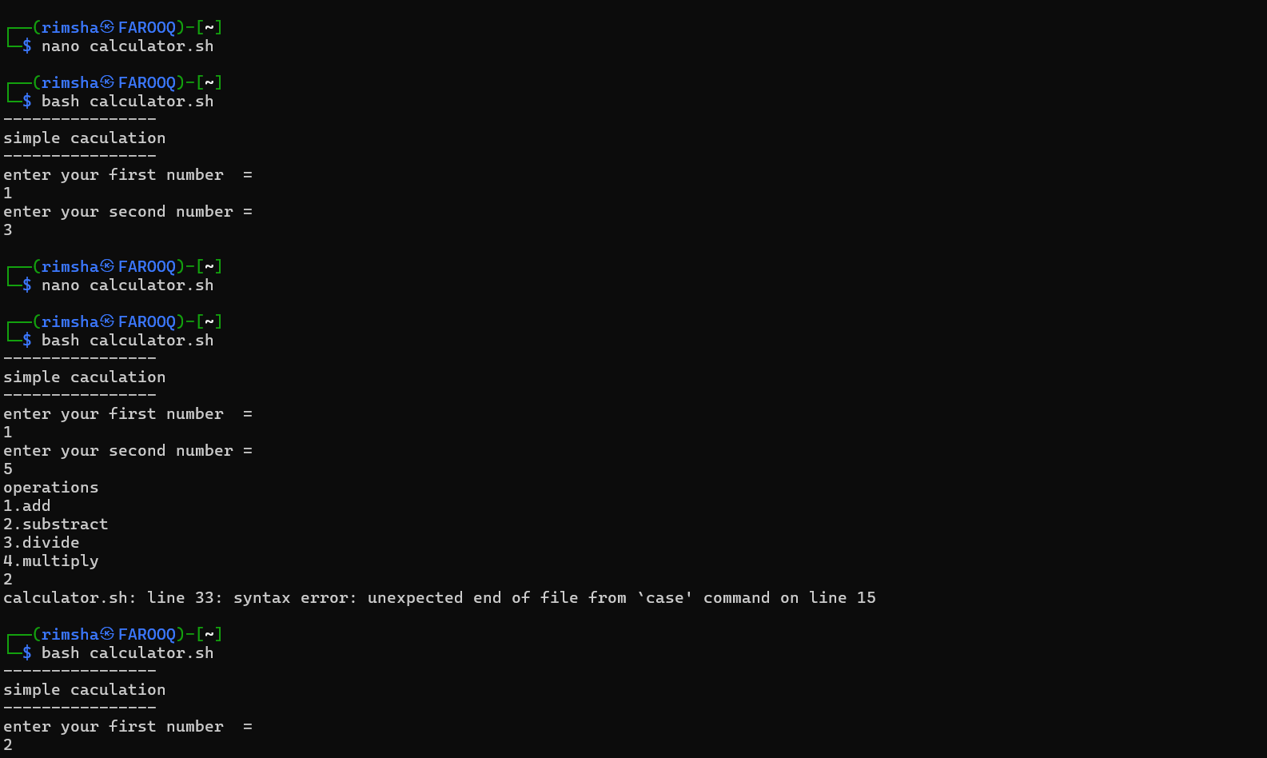
Figure 2: Early runs of the script and the case syntax error
Step 3: Test the working script
After the fix the script worked for each operation I tested. Here are the results shown in the screenshots:
First number | Second number | Choice | Result shown
1 | 3 | 2 (subtract) | -2
2 | 4 | 3 (divide) | 0
2 | 4 | 4 (multiply) | 8

The divide test gave 0 because Bash arithmetic works with whole numbers only, so 2 divided by 4 is cut down to 0 instead of 0.5. Decimal division would need a tool such as bc.
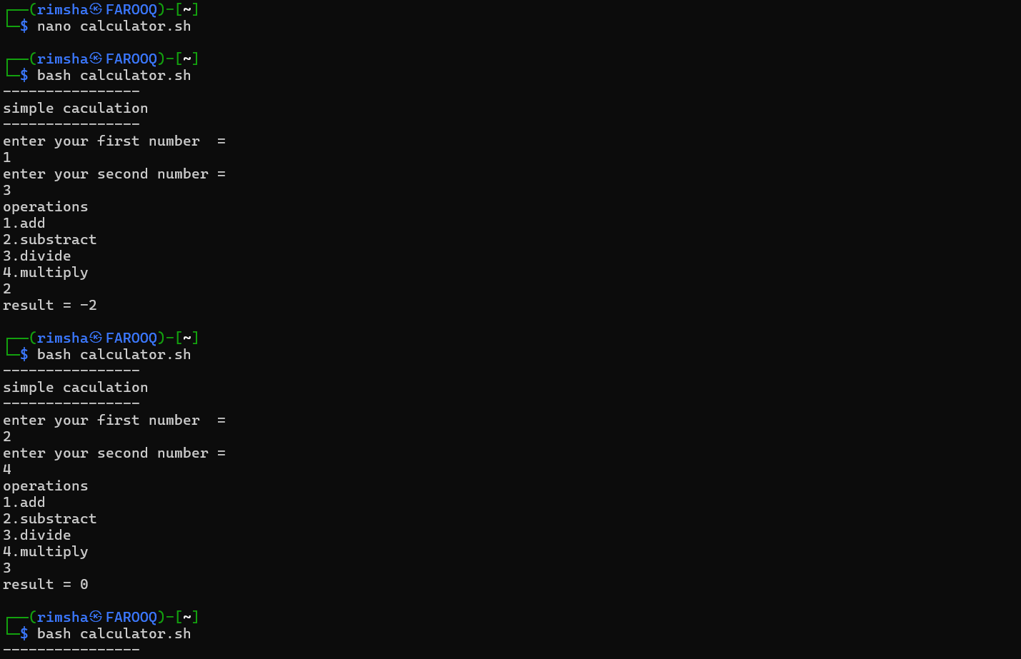
Figure 3: Subtract (1 - 3 = -2) and divide (2 / 4 = 0) tests
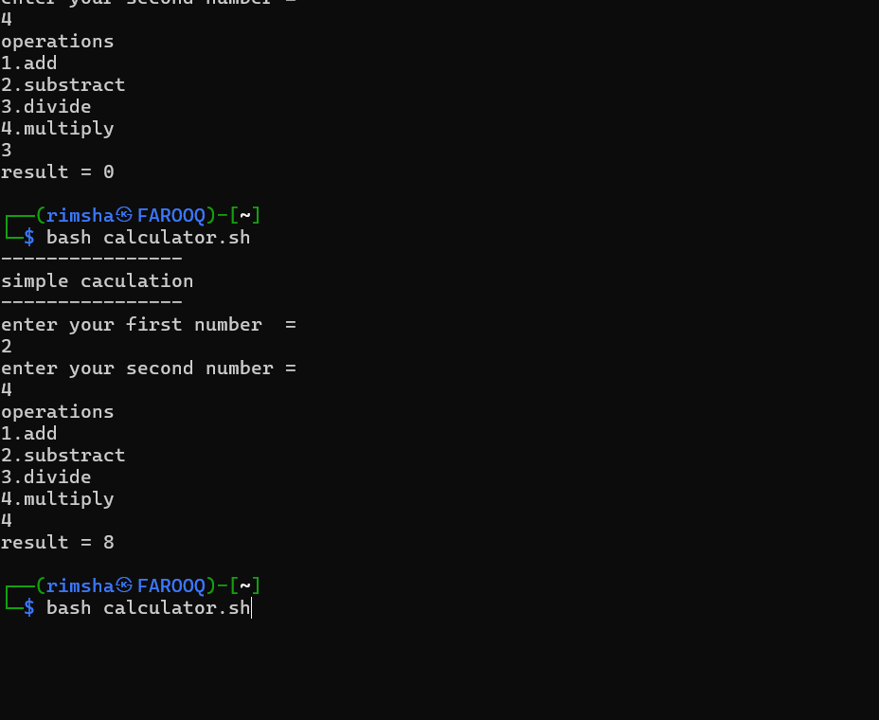
Figure 4: Multiply test (2 x 4 = 8)

